**TextView with Example in Android Studio**

In Android, TextViewdisplays text to the user and optionally allows them to edit it programmatically. TextView is a complete text editor, however basic [class](http://abhiandroid.com/java/class-objects) is configured to not allow editing but we can edit it.

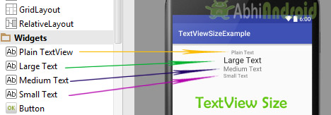

View is the parent class of TextView. Being a subclass of view the text view component can be used in your app’s GUI inside a ViewGroup, or as the content view of an activity.

We can create a TextView instance by declaring it inside a layout([XML](http://abhiandroid.com/ui/xml" \t "_self) file) or by instantiating it programmatically(Java Class).

**TextView code in**[**XML**](http://abhiandroid.com/ui/xml)**:**

<TextView android:id="@+id/simpleTextView"

android:layout\_width="wrap\_content"

android:layout\_height="wrap\_content"

android:text="AbhiAndroid" />

**TextView code in JAVA:**

TextView textView = (TextView) findViewById(R.id.textView);

textView.setText("AbhiAndroid"); //set text for text view

**1. Attributes of TextView:**

Now let’s we discuss about the attributes that helps us to configure a TextView in your [xml](http://abhiandroid.com/ui/xml) file.

1. **id:** id is an attribute used to uniquely identify a text view. Below is the example code in which we set the id of a text view.

<TextView

android:id="@+id/simpleTextView"

android:layout\_width="wrap\_content"

android:layout\_height="wrap\_content"/>

1. **gravity:**The gravity attribute is an optional attribute which is used to control the alignment of the text like left, right, center, top, bottom, center\_vertical, center\_horizontal etc.

Below is the example code with explanation included in which we set the center\_horizontal gravity for text of a TextView.

<TextView

android:id="@+id/simpleTextView"

android:layout\_width="fill\_parent"

android:layout\_height="wrap\_content"

android:text="AbhiAndroid"

android:textSize="20sp"

android:gravity="center\_horizontal"/> <!--center horizontal gravity-->

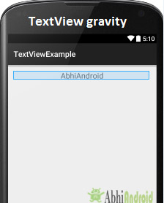

1. **text:** text attribute is used to set the text in a text view. We can set the text in [xml](http://abhiandroid.com/ui/xml) as well as in the java class.

Below is the example code with explanation included in which we set the text “AbhiAndroid” in a text view.

<TextView

android:id="@+id/simpleTextView"

android:layout\_width="wrap\_content"

android:layout\_height="wrap\_content"

android:layout\_centerInParent="true"

android:textSize="25sp"

android:text="AbhiAndroid"/><!--Display Text as AbhiAndroid-->

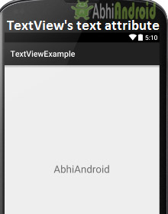

**In Java class:**

Below is the example code in which we set the text in a textview programmatically means in java class.

TextView textView = (TextView)findViewById(R.id.textView);

textView.setText("AAAAAAAA"); //set text for text view

1. **textColor:** textColor attribute is used to set the text color of a text view. Color value is in the form of “#argb”, “#rgb”, “#rrggbb”, or “#aarrggbb”.

Below is the example code with explanation included in which we set the red color for the displayed text.

<TextView

android:id="@+id/simpleTextView"

android:layout\_width="wrap\_content"

android:layout\_height="wrap\_content"

android:text="AbhiAndroid"

android:layout\_centerInParent="true"

android:textSize="25sp"

android:textColor="#f00"/><!--red color for text view-->

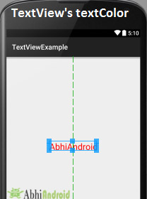

**In Java class:**

Below is the example code in which we set the text color of a text view programmatically means in java class.

TextView textView = (TextView)findViewById(R.id.textView);

textView.setTextColor(Color.***RED***); //set red color for text view

1. **textSize:** textSize attribute is used to set the size of text of a text view. We can set the text size in sp(scale independent pixel) or dp(density pixel).

Below is the example code in which we set the 20sp size for the text of a text view.

<TextView

android:id="@+id/simpleTextView"

android:layout\_width="wrap\_content"

android:layout\_height="wrap\_content"

android:text="AbhiAndroid"

android:layout\_centerInParent="true"

android:textSize="40sp" /><!--Set size-->

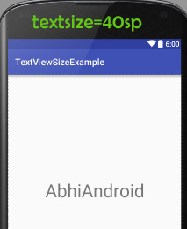

**In Java class:**

Below is the example code in which we set the text size of a text view programmatically means in java class.

TextView textView = (TextView)findViewById(R.id.textView);

textView.setTextSize(20); //set 20sp size of text

1. **textStyle:** textStyle attribute is used to set the text style of a text view. The possible text styles are bold, italic and normal.  If we need to use two or more styles for a text view then “|” operator is used for that.

Below is the example code with explanation included in which we set the bold and italic text styles for text.

<TextView

android:id="@+id/simpleTextView"

android:layout\_width="wrap\_content"

android:layout\_height="wrap\_content"

android:text="AbhiAndroid"

android:layout\_centerInParent="true"

android:textSize="40sp"

android:textStyle="bold|italic"/><!--bold and italic text style of text-->

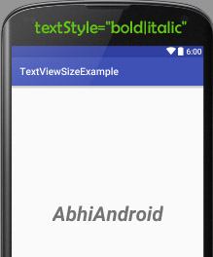

1. **background:** background attribute is used to set the background of a text view. We can set a color or a drawable in the background of a text view.
2. **padding:** padding attribute is used to set the padding from left, right, top or bottom. In above example code of background we also set the 10dp padding from all the side’s of text view.

Below is the example code with explanation included in which we set the black color for the background, white color for the displayed text and set 10dp padding from all the side’s for text view.

<TextView

android:id="@+id/simpleTextView"

android:layout\_width="wrap\_content"

android:layout\_height="wrap\_content"

android:text="AbhiAndroid"

android:layout\_centerInParent="true"

android:textSize="40sp"

android:padding="10dp"

android:textColor="#fff"

android:background="#000"/> <!--red color for background of text view-->

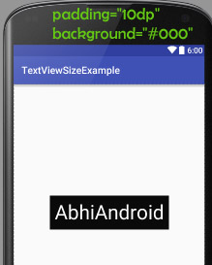

**In Java class:**

Below is the example code in which we set the background color of a text view programmatically means in java class.

TextView textView = (TextView)findViewById(R.id.textView);

textView.setBackgroundColor(Color.***BLACK***);//set background color

**Example of TextView:**

Below is the example of TextView in which we display a text view and set the text in [xml](http://abhiandroid.com/ui/xml) file and then change the text on [button](http://abhiandroid.com/ui/button) click event programmatically. Below is the final output and code:

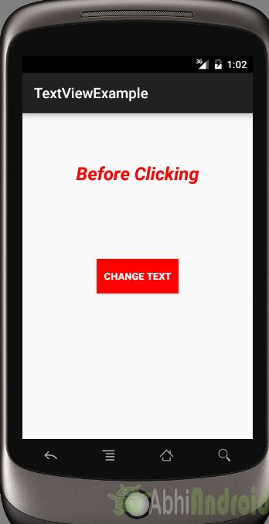

**Step 1:** [Create a new project](http://abhiandroid.com/androidstudio/start-create-project) and name it textViewExample.

Select File -> New -> New Project. Fill the forms and click "Finish" button.

**Step 2:** Open res -> layout -> [xml](http://abhiandroid.com/ui/xml) (or) activity\_main.[xml](http://abhiandroid.com/ui/xml) and add following code. Here we will create a button and a textview in [Relative Layout](http://abhiandroid.com/ui/relative-layout).

<RelativeLayout xmlns:android="http://schemas.android.com/apk/res/android"

xmlns:tools="http://schemas.android.com/tools"

android:layout\_width="match\_parent"

android:layout\_height="match\_parent"

android:paddingBottom="@dimen/activity\_vertical\_margin"

android:paddingLeft="@dimen/activity\_horizontal\_margin"

android:paddingRight="@dimen/activity\_horizontal\_margin"

android:paddingTop="@dimen/activity\_vertical\_margin"

tools:context=".MainActivity">

<TextView

android:id="@+id/simpleTextView"

android:layout\_width="wrap\_content"

android:layout\_height="wrap\_content"

android:layout\_centerHorizontal="true"

android:text="Before Clicking"

android:textColor="#f00"

android:textSize="25sp"

android:textStyle="bold|italic"

android:layout\_marginTop="50dp"/>

<Button

android:id="@+id/btnChangeText"

android:layout\_width="wrap\_content"

android:layout\_height="wrap\_content"

android:layout\_centerInParent="true"

android:background="#f00"

android:padding="10dp"

android:text="Change Text"

android:textColor="#fff"

android:textStyle="bold" />

</RelativeLayout>

**Step 3:** Open app -> java -> package and open MainActivity.java and add the following code. Here we will change the text of TextView after the user click on Button.

package example.abhiandriod.textviewexample;

import android.graphics.Color;

import android.support.v7.app.AppCompatActivity;

import android.os.Bundle;

import android.view.Menu;

import android.view.MenuItem;

import android.view.View;

import android.widget.Button;

import android.widget.TextView;

public class MainActivity extends AppCompatActivity {

@Override

protected void onCreate(Bundle savedInstanceState) {

super.onCreate(savedInstanceState);

setContentView(R.layout.activity\_main); //set the layout

final TextView simpleTextView = (TextView) findViewById(R.id.simpleTextView); //get the id for TextView

Button changeText = (Button) findViewById(R.id.btnChangeText); //get the id for button

changeText.setOnClickListener(new View.OnClickListener() {

@Override

public void onClick(View view) {

simpleTextView.setText("After Clicking"); //set the text after clicking button

}

});

}

}

**Output:**

Now [run the app](http://abhiandroid.com/androidstudio/run-app-avd-emulator-android-studio) in Emulator and click on the button. You will see text will change “After Clicking”.

